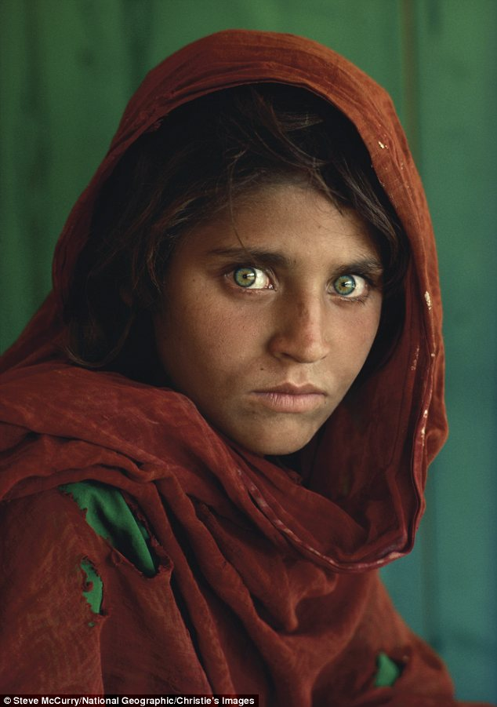

Visual literacy, to me, is the ability to derive context and meaning from an image using defined “tools” like element of art and principle of design to aid in our description and understanding.

Brian Kennedy in his lecture on Visual Literacy stated the following:
VISUAL LITERACY ENABLES:
• Interpreting content of visual images
• Examining the social impact of visual images
• Discussion of their purpose, audience
and ownership
• The ability to visualize internally

The first time, I started my journey towards Visual Literacy was in June 1985 when National Geographic published the above picture as their cover. The picture, named Afghan Girl by Steve McCurry is an amazing piece of journalistic work. Although, I could not define it at the time, the elements of art such as color and texture drew me into the picture.
The girl’s arresting green eyes draw you into the picture. The stare is haunting almost vacant. Even though this girl is aesthetically beautiful, you can see the trials and tribulations she has gone through in her short life from the texture of her skin and the worry creases around her mouth. This girl is acquainted with loss and suffering. The clothes are colorful yet threadbare with holes that show the fabric underneath.
This picture shares her story visually to the viewer. You are drawn to find out more about her and her community. Why does she look so sad? What is going on in her world? This picture became the most recognized photo in the history of National Geographic. Although, I did not have the toolbox to describe what I was seeing at the time, my heart went out to this girl around my age who had been through so much in her time on this planet.

