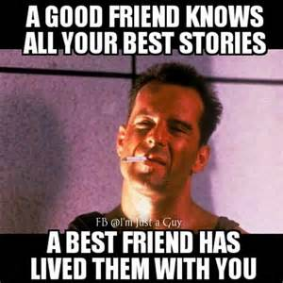

My blog today is on memes. A good meme, in my opinion, is one that visually expresses the sentiment both visually and textually. This meme does just that. The picture of Bruce Willis from “DieHard” is one of coolness. You can tell he has just been through something but came out just fine. The words of the meme tell the difference between good and best friends. I love the idea that a best friend has been by your side when “stuff” went down. That is so true! My best friend is one that was right there during the good and the bad and I am very lucky to have her in my life. Our favorite saying is that we both have other friends but it would be either her or myself that would help the other hide the bodies. 😊

This meme really resonates with me about friendship. The fact that the subject has obviously gone through some conflict and difficulty ties to the fact that there are hills and valleys in everyone’s life. The text that a best friend lived them with you reminds the viewer of the importance of friendship and sharing one’s life with others. Humans are social animals – this meme reminds us of that and the importance of friendship.

