In my opinion, James Paul Gee is asserting that language has to be viewed through the lens of intention (doing) as well as meaning Gee states "language is a key way we humans make and
break our world, our institutions, and our relationships through how we deal with social good" (Gee-9,10). For example, let’s look at the phrase "bless your heart." This is a common phrase used in the south and other parts of the country. If we look at the meaning of the words and ignore the intention these words seem benign and positive. Blessings are generally considered to be good things so on the surface this is a positive statement. That said, the intention of those who use the phrase "bless your heart" is anything but positive. The intention of the speaker is to form a negative judgement on the recipient of the phrase. The implication is that the person is "less than" the speaker and so the speaker is showing a mix of charity and pity by reciting the phrase.
Our political system and culture definitely defines the citizen’s discourse. For example, opinions on sexuality and depictions of women can vary significantly based on the region and the culture of the inhabitants. I think it definitely impacts visual communications in that the creator of the image must keep in mind the mores of a culture if they are to be successful in communicating their message. One of the best places to see this are advertisements. If we are to hold that the purpose of advertisement is to entice the viewer into buying the product, then the image will need to conform to the cultural standards of where it is being displayed or else the desired effect will not be achieved.
Here are two advertisements for Shampoo - One is from Saudi Arabia and one is from Brazil. See if you can identify which one is which just by the image itself.
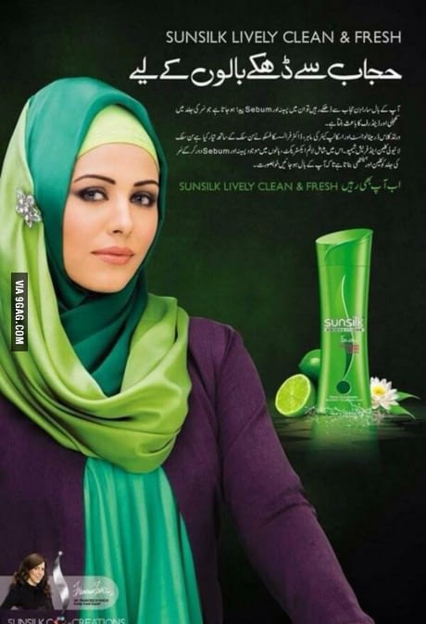
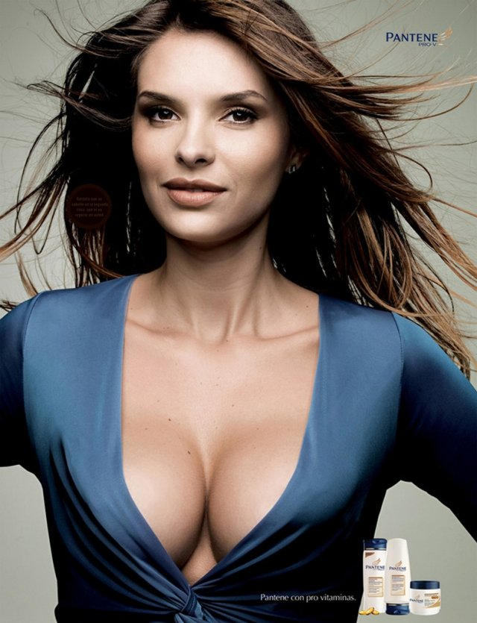

Where you able to guess which one is which? What I found fascinating about these pictures is the fact that hair is not the focal point of the ad. If you did not see the shampoo images to the right you may not know they were shampoo advertisements at all.
The first image does not show her hair. It seems almost counter intuitive to have a shampoo advertisement feature a woman in a burka.
The second image, if not for the shampoo in the right-hand side, would look to me like a bra or plastic surgery advertisement and not shampoo. I have to be honest and admit that my eyes were not focused on her luxurious hair in this advertisement. My eyes did focus on something but it was not her flowing locks of luxurious follicles.
I think that an understanding of discourse theory would be extremely beneficial because language has meaning and intention and it is the responsibility of the transmitter of language to be sure that their meaning and intention are coming across correctly.

Works Cited
Gee, James Paul. An Introduction to Discourse Analysis Theory and Method. 3rd ed., New York, NY, Routledge, 2011.

