Prescription Drug Emoji Submission
To Unicode Consortium
From Daniel Alfonso
Date 11/08/2017

Introduction:
I am requesting the addition of a smiley face emoji with jagged edges on the right and bottom side to represent the dissonance users could feel while using certain prescription drugs.
According to the National Institute of Health the following statements can be made after studying the effects of reducing or eliminating anti-depressants and the increase risk of suicidal tendencies.
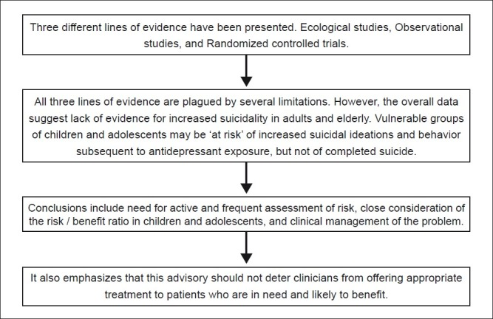
(Nischal et al.).
The emoji has blurred edges on the side to indicate the feeling of distance and difference one can experience while using prescription medication. The emoji’s image would be used to start conversations with medical or health care providers about the effects of medication on users.
Sometimes it can be difficult for people to share their feelings of dissonance when using medication, especially when this medication is needed on a daily basis. I would suggest this to be used as the starting point of a conversation around side effects, physical and mental. I chose the picture of the happy face since it is very familiar and is used to indicate happiness and the status quo.
So in summation, I would suggest adding this emoji to the Unicode emoji list. It could help to start a conversation around withdrawal systems from anti-depressants or any prescription medication.
- Identification:
  - CLDR short name: Disconnected Happy Face
  - CLDR keywords: disconnected – dissonance – withdrawal
- Images:

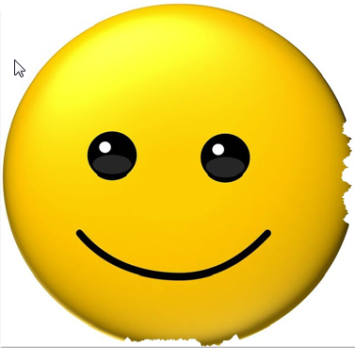

- Selection Factors – Inclusion
- Compatibility
N/A
- Expected Usage Level
  - Frequency
According to NBC News in 2016 1 out of every 6 people in the US took anti-depressants and that is only the US. Worldwide it is much much more so I would confidently state that this emoji would be useful and used as part of the conversation around effects of prescription drugs.
(https://www.nbcnews.com/health/health-news/one-6-americans-take-antidepressants-other-psychiatric-drugs-n695141)
  - Multiple Usages
It can be used to discuss any effects for any prescription drug not only anti-depressants.

  - Use in sequences
Could be used with face with bandage U+1F915 to indicate not feeling well.
- Selection factors – Exclusion
  - Overly Specific
    - The emoji is not overly specific because it can refer to any number of prescription drugs and their effects. It could also be used to indicate a person’s mental state that they are out of sorts.
  - Already representable
    - To my knowledge, there is not an emoji at this time that could be used to reference this.
  - Logos, Brands UI icons, signage, specific people, deities
  - Transient
    - As more and more people start to take prescription medication the need to address adverse side effects will just increase.
  - Faulty Comparison
    - N/A
- Sort Location
  - Category
    - Smileys and People
      - Face Sick
- Other Information
  - Character is uncased
  - Character is a stand-alone symbol
  - Character is not white space nor does it separate other characters
  - Character has no numeric value
  - Character can combine with other emoji characters
  - Character is not a combining character
  - Character is not a punctuation character

Based on our assignment a few weeks ago, I created a meme using my emoji to show what a poster or sign could look like in a healthcare provider’s office.

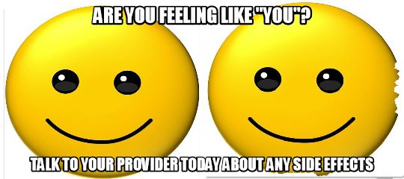

I used Snagit Editor by Techsmith to create the emoji and Memedad.com to create the meme.

Works Cited

Nischal, Anil, et al. "Suicide and Antidepressants: What Current Evidence
Indicates." PCB - NCBI, National Institues of Health, Dec. 2012,
www.ncbi.nlm.nih.gov/pmc/articles/PMC3353604/.

